

UI

Proce

Robotic Process Automation

Path Automation

ss design document

Process Design Document – Verify Account Positions for Client for ACME Systems Inc.

0
0

Process Design Document History

Date Version Role Name Organizati on
01.08.2017 1.0 Author Olfa Ben Taarit ACME

Systems Inc.
Function Comments

SME Creation v 1.0

09.08.2017 1.2 Reviewer Vrabie Stefan Ui Path BA Approved v 1.0

Table of Contents

1. Introduction ............................................................................. Error! Bookmark not defined.

1.1 Purpose of the document................................................... Error! Bookmark not defined.

1.2 Objectives.......................................................................... Error! Bookmark not defined.

1.3 Process key contacts......................................................... Error! Bookmark not defined.

1.4 Additional source(s) of process documentation ................. Error! Bookmark not defined.

2. AS IS Process Description ..................................................................................................... 5

2.1 Process overview ............................................................................................................. 5

2.2 High Level process diagram ............................................................................................. 7

2.3 Detailed Process map....................................................................................................... 8

2.4 Detailed Process Steps ...................................................................................................10

2.5. Exceptions handling .......................................................................................................13

2.6 Error mapping and handling .............................................. Error! Bookmark not defined.

2.7 In-Scope application details............................................... Error! Bookmark not defined.

2.7.1. Detailed application field mapping.............................. Error! Bookmark not defined.

2.7.2 XML TO PDF Mapping – Part #1 Header .................... Error! Bookmark not defined.

3. Development details................................................................ Error! Bookmark not defined.

3.1 Prerequisites for development ........................................... Error! Bookmark not defined.

3.2 Password policies.............................................................. Error! Bookmark not defined.

3.3 Credentials and asset management .................................. Error! Bookmark not defined.

3.4 Operating Environment...................................................... Error! Bookmark not defined.

4. Testing preliminary details....................................................... Error! Bookmark not defined.

4.1 Alpha testing..................................................................... Error! Bookmark not defined.

4.2 User Acceptance Test ....................................................... Error! Bookmark not defined.

5. Annexure ................................................................................ Error! Bookmark not defined.

5.1 UIPATH automated process details................................... Error! Bookmark not defined.

Glossary.................................................................................. Error! Bookmark not defined.

1. Introduction

The Process Design Document describes the business processes chosen for automation using
UIPath Robotic Process Automation (RPA) technology.

The document describes the sequence of steps performed as part of the process, the conditions and rules of the process prior to automation. This design document serves as a base documentation for developers to collect the details required for robotic automation of the same business process.

The process has been selected for RPA as part of the larger project initiative conducted within
ACME Systems Inc., the Finance and Accounting department.

The objective of this process automation is linked to the project business case and it is mainly intended to:

➢ Deliver faster processing
➢ Reduce duration of time-consuming activities
➢ Leverage automation to improve the department`s overall performance and reliability.



The design document includes concise but complete requirements of process and it is built based on the inputs provided by the process Subject Matter Expert (SME).

For escalation points, please review the table below:

Role Name Date of action Notes
Process SME Aurel Vlaicu TBD Point of contact for questions related to business exceptions and passwords

Reviewer / Owner Approval for production

Sergiu Celibidache

Nicoale Herlea

tBD TBD

POC for process exceptions. Escalations, Delays,

General information about the process selected for RPA, prior to automation:

Process full name

Function
AS IS process details

Verify Account Positions

Accounts Payable

Department Finance and Accounting

Process short description

(operation, activity, outcome)
Compare the transactions of system 1 and system 3. If there are differences, mark them in the work item.

Role required for performing the process
AP Process Associate

Process schedule Daily, Monday to Friday, 9 am – 6 pm

# of items processes /month ~4500

Average handling time per item
2 min

Peak period (s) End of month, usually from 20th to 28th day of each month

# of FTEs supporting this 10
activity

Level of exception rate ~1000 invoices have missing details

Input data Client Account Number

Account Transactions

Output data Account amount Matches?

2.1.1 In scope for RPA

The activities and exception in of scope for RPA, in this automation workflow/sequence are listed here:

➢ Full Scope of the process for RPA - to be 100% automated

2.1.2 Out of scope for RPA

There are no activities out of scope for RPA


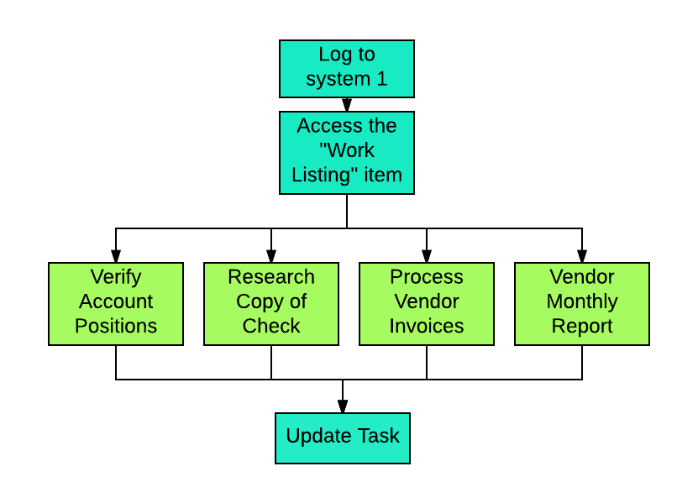

Process Design Document – Verify Account Positions for Client for ACME Systems Inc.

7


This chapter presents the chosen process in detail, which enables the developer to build the automated process.

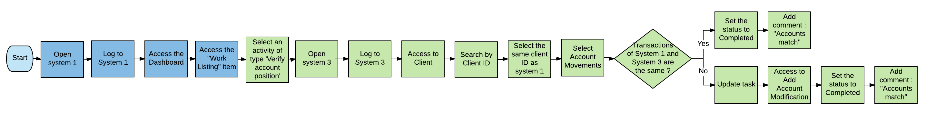

Step Short Description

1.1 Open the ACME System 1 Web Application

1.2 Log in to System 1 (input data: email and password)

1.3 Access the Dashboard, it’s the central location where the user can pick a specific menu item

1.4 Access the Work Items Listing to consult all the available tasks to perform (Output data: task)

1.5 Open the ACME System 3 Desktop Application

1.6 Log in to ACME System 3 using the same credentials

1.7 For each activity of the type WI1 perform the following steps

Process Design Document – Verify Account Positions for Client for ACME Systems Inc.

8
8


1.7.A Open the Details page for the selected activity and Read Account Number and Account Amount

1.7.B Access the Clients -> Search for Client by Client ID menu option in ACME System 3

1.7.C Enter Client based on the ID and double click the Client Name. Also check “Include Inactive Clients” as
sometimes even active clients will not be found otherwise.

1.7.D Open the Accounts page for the selected client

1.7.E Double click the current account based on its number

1.7.F Calculate the sum of all transactions for the specified account

1.7.G Go back to the Work Item Details and open the “Update Work Item”

1.7.H If the sum of all transactions in System 3 is equal to the Account amount in System 1

Yes No

1.8 Set the status to Completed 1.9 Set the status to Completed

Add comment: ''Account value matches'' Add comment: ''Account has difference of xxx''

Process Design Document – Verify Account Positions for Client for ACME Systems Inc.

9


Complete and concrete process steps at keystroke level or clicks to be defined with screenshots. (If there are any data restrictions, mask important data like Policy Number, Customer ID, bank account etc).

S
T Step action
E description
P

Screenshot Expected result Remarks

Possible exception:

1.1
Open the ACME
System 1 Web
Application
Opening of a screen

: System 1 Web App

- Handle exception if
Web app not available

1.2

Log in to System 1 (input data: email and password)

Access to the dashboard
Possible exception:

- Handle exception if Incorrect email or Password

1.3
Access the Dashboard, it’s the central location where the user
can pick a specific menu item

1.4
Access the Work Items Listing to consult all the available tasks to perform (Output data: task)

List of tasks
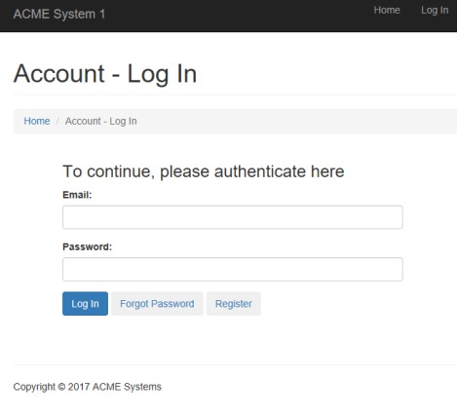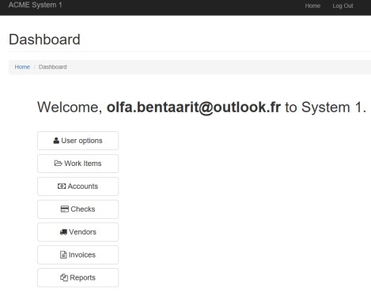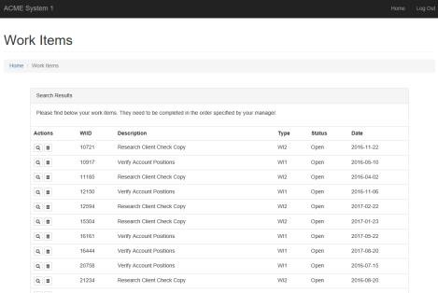

Process Design Document – Verify Account Positions for Client for ACME Systems Inc.

10
10

1.5

Open the ACME System 3 Desktop Application
Possible exception: Handle exception if no task of type ‘Process
Vendor Invoice’ exist

N/a N/a

1.6
Log in to ACME System 3 using the same credentials

1.7

1.7.A
For each activity of the type WI1 perform the following steps Open the Details page for the selected activity and Read Account Number and Account Amount
N/a N/a

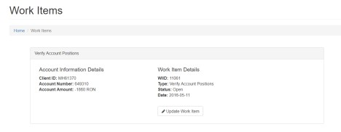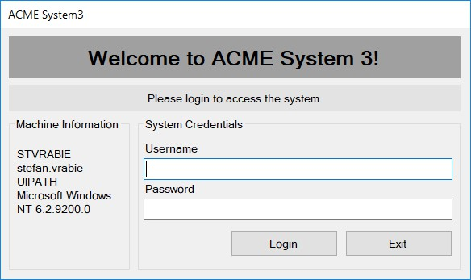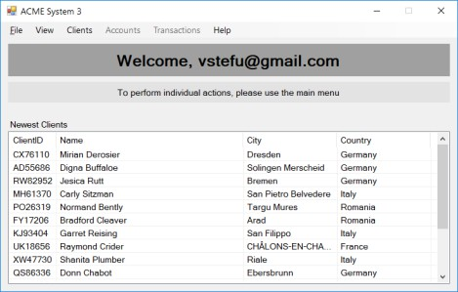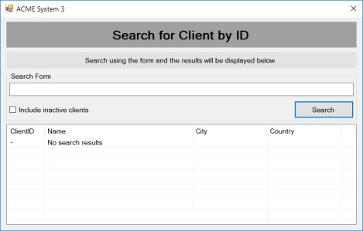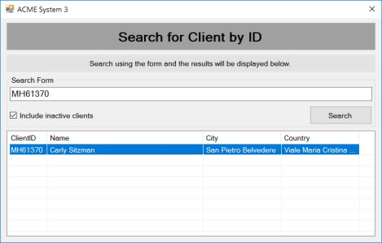N/a N/a

N/a N/a

1.7.B
Access the Clients
-> Search for
Client by Client ID menu option in ACME System 3

1.7.C
Enter Client based on the ID and double click the Client Name. Also check “Include Inactive Clients”
as sometimes
even active clients will not be found
otherwise.
N/a N/a

N/a

1.7.D
Open the Accounts page for the selected client

N/a

N/a

1.7.E
Double click the current account based on its number

N/a

N/a

1.7.F
Calculate the sum of all transactions for the specified account

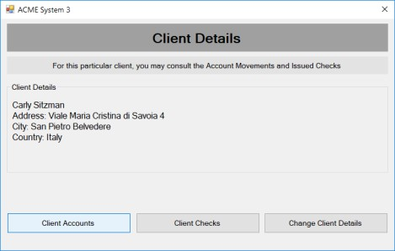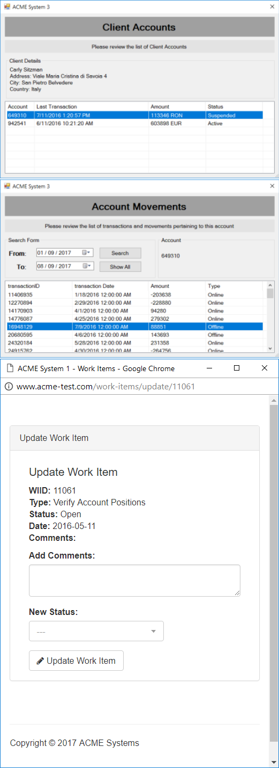N/a

N/a

1.7.G
Go back to the Work Item Details and open the “Update Work Item”

N/a

1.8
If the sum of all transactions in System 3 is equal to the Account amount in System

N/a
N/a

1.9
1 Set the status to Completed and add comment:
''Account value matches''
If the sum of all transactions in System 3 is equal to the Account amount in System
1 Set the status to
Completed and add comment:
''Account value matches''

N/a

N/a

Exceptions identified in the automation process can be classified as:

Area Known Unknown

Business Previously encountered. A scenario is defined with clear actions and workarounds for each case.
New situation never encountered before – it should not really happen. It can be caused by external factors.

Based of the above criteria the table below should reflect all exceptions identifiable in the process and map the expected action the robot needs to take for each exception.

Below are the exceptions captured during the process study. These are known exceptions, met in practice before. For each exception an action is defined.

Insert as many rows as required in the table, to capture all exceptions in a comprehensive list.

E Exception name Step where
# exception is encountered
Parameters Action to be taken

1 Web app not available
Step # 1.1 If Web app is not available
Send email to exceptions@acme-test.com

“Hello,
System 1 web App could not be open because the web app is not
available’’

2 Incorrect email or password
Step # 1.2 If message for incorrect username or password
exist
Send email to exceptions@acme-test.com

“Hello,
The username or the email is incorrect. Please check and restart
Thank you’’

3 No task of type WI1 Step # 1.5
Wait 30 min and retry

For all the other unanticipated or unknown exceptions, the robot should send an email notification at exceptions@acme-test.com with the original email and error message screenshot attached.

A comprehensive list of all the errors or warnings or notification should be consolidated here with the description and action to be taken, for each, by the Robot.

Errors identified in the automation process can be classified as:

Area Known Unknown

Technology Experienced previously, action plan or workaround available for it.
New situation never encountered before, or may happened independent of the applications used in the process.

Based of the above criteria the table below should reflect all errors identifiable in the process and map the expected action the robot needs to take for each error.

Insert as many rows as required in the table, to capture all errors in a comprehensive list.

E Error

#
name
Step where error is encountered
Parameters Action to be taken

Application Crash / Internal Server Error
Any step Error message
Refresh / Retry

Send email with screenshot to exceptions@acme-test.com

Close application and run the sequence again

Application unresponsive / page
not loading
Any step No response /

blank page
Wait 5 minutes and retry 2 times.

Close application and run the sequence again

*Feel free to insert an additional error mapping table for more complete explanation.

The table below lists all the applications that are used as part of the process automated, at various steps in the flow.

# Application name

& Version
System

Lang.
Login module Interface Environment/ Access
method
Comments

1 ACME System 1 EN Web Web Web

Browser

2 Microsoft Excel EN n/a Client Local desktop

3.

• Development or testing environment will be provided for development.

• Development/testing environment is an exact replica of production environment.
• Dedicated system and application access are given to developers with adequate permission.

Users manage their own passwords. There are no special policies in place.

3.3 Credentials and asset management

Log on details (user IDs and passwords) should be stored under “Windows Credential Manager”
or “UIPath Orchestrator Assets”

4. Testing preliminary details

Below are the various stages in testing. Update each item with Testing plan.

Testing Owner Start date End

date
# of test

cases
% of

Success
Status

Alpha RPA Project

Lead

User Acceptance

Testing Process SME

Regression

Testing Process Owner

Security Testing Client IT / Info

Sec Team



Alpha and Beta Testing: Alpha testing is the testing done by RPA developers and RPA project lead after development.

Business operations team creates test cases and provides test data for development and testing. This is due to be provided by POC.

5. Annexure

Note: this step is to be filled in after automation process is complete

Automation overview: (time to dev, test, etc)

Robots type: Back Office Robot

Level of human intervention required:

Use of Orchestrator:

Exceptions recorded in automation process: Errors identified in the automation process: Challenges identified in the automation process: Lessons Learned:
Any adjustments done in the automation process to facilitate (steps tweaked from the human way of working to an automatic programing way of working).All activities which have been performed to tweak the as is process to enable higher rates of automation on the process.

➢ Process Assumption
➢ Input data assumption
➢ Number or types of input to be received
➢ Skip logon interface and collect back end details
➢ Extract data from backend without opening the file…
➢ Data conversion / formatting

Reporting: The details and format of the logging available in the workflow must be specified here. (Whether it is creating local log reports or Orchestrator logs).

The format should be specified by the business users.

Workflow and scripts: A brief of each workflow and the sequence in which are executed should be described here.

